Setting The basic react apps:

One of the way is to provide **npx create-react-app folderName**

Certainly! The term **npx create-react-app 01basicreactapp** is a command used in the context of creating a new React.js application using the "Create React App" tool. Let me break it down in simple words:

1. **npx:**
   * **npx** is a tool that comes with npm (Node Package Manager). It allows you to execute packages directly without having to install them globally or locally. In this case, it's being used to run the **create-react-app** package.
2. **create-react-app:**
   * **create-react-app** is a command-line tool provided by the React team. It helps you set up a new React.js application with a sensible default project structure and build configuration. It simplifies the process of creating a new React project by handling many configuration details for you.
3. **01basicreactapp:**
   * This is the name you are giving to your new React application. You can replace "01basicreactapp" with any name you prefer for your project. It will create a folder with this name, and your React project will be set up inside that folder.
4. **In Simple Words:** When you run the command **npx create-react-app 01basicreactapp**, you are telling your computer to use **npx** to execute the **create-react-app** tool with the argument "01basicreactapp." This results in the automatic creation of a new React.js project with the name "01basicreactapp." The tool sets up the necessary files, folders, and configuration for a basic React application, saving you the manual effort of setting up these details yourself.
5. After running this command, you can navigate into the newly created folder ("01basicreactapp") and start working on your React application. This command is a convenient and quick way to bootstrap a new React project without having to set up all the configuration manually

**This is a bulky way to create react apps and its time consuming as well**

So we will be using another way of creating react projects

**Another way is to set the basic React project using Vite**

You have to run the **series of commands** in order:

npm create vite@latest

You have to give the project name

You have to give the package name same as project name

You have to select react from dropdown

You have to select JS from dropdown

Once the project is created use cd projectName

npm install

npm run dev

**Understanding the Basic Folder structure of react jitha aapn kam karnar:**

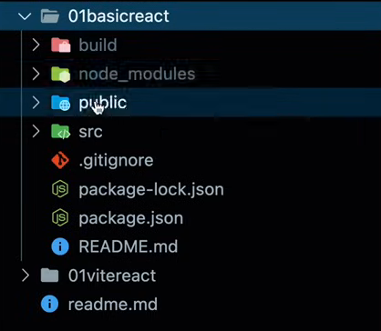

Jevde pn dependencies mala package.json madhe distayt te download or install houn **node_modules** madhe bastat

Most of the kam je asnar ahe te **source folder** madhe asnar kiva **public folder** madhe asnar

Talking in context of create-react-app wala react project

**In Public Folder:**

Public folder madhe important file ahe **index.html** which is where all the component code will be painted by react as and when needed …during runtime

This is the reason why it is called as single page application

**In Source Folder:**

Index.js ani App.js are important files in this

Index.js pasun ek virtual dom create hotay memory madhe and which maps whatever components are there in the browser dom.

App.js pasun aapn index.js madhe components pathvnar which will render them.